<Your Company>

liposcan testing results & feedback

Client Name
DOB
Report Date | - [Select Date]
Feedback by
Important: This information is general in nature and acts as a guide only. It is not intended to be interpreted as providing advice on treatment. Any and all information should be discussed with your medical practitioner or treating specialist as appropriate. It is vital that information is placed into your specific clinical context for informed decision making by medically trained personnel. The practitioners are qualified Dietitians and as such can provide information on dietary approaches not medical treatment/s. So please ensure you discuss any and all information you get with your medical practitioner/s before adopting any dietary or medication intervention/s or change. The final report you receive will need to be interpreted by your designated medical practitioner. Each practitioner works independently to this website. Queries about feedback regarding dietary services, tests or products should always be directed to the practitioner involved in your care.

Fat metabolism:
Triglycerides and Total Cholesterol (TC)
Total Cholesterol is a limited marker because it includes and is thus complicated by protective HDL levels. A better marker is what is called non-HDL Cholesterol, and this is easily calculated by subtracting the HDL level from the Total Cholesterol (TC) level
Your result | Level | Comment
Total Cholesterol | Choose an item.
Triglycerides | Choose an item. | Triglycerides are elevated with high carbohydrate intake (Aude, Agatston et al. 2004), in insulin-resistant states like prediabetes, the Metabolic Syndrome and Diabetes. Triglycerides are an independent risk for vascular damage and disease and should not be ignored.
HDL | Choose an item. | HDL the 'Good' cholesterol transporter removes and transports cholesterol from the arteries and the body to the liver. Medications that elevate HDL have never been shown to be of benefit, and this may be because the HDL function of transporting cholesterol to the liver may be impaired for genetic or diet/lifestyle reasons. So function not level is important and drugs that improve HDL function may be beneficial in future  There is an inverse relationship between HDL and Triglycerides so if we divide HDL/Triglycerides then if the triglycerides are high, the HDL level will be low, i.e. an inverse (opposite) response (Dunn 2017).
LDL/HDL | Choose an item.
VLDL | Choose an item. | VLDL carries triglycerides. It is raised with a high carbohydrate diet, insulin resistance and high alcohol intake. It is a cardiovascular risk and lowering triglycerides will lower VLDL
IDL | Choose an item.
Total Cholesterol:HDL |  | This ratio is the Total Cholesterol divided by the HDL Cholesterol. This ratio should be 3.5:1 or less.
Non-HDL Level  (Total Chol minus HDL) |  | This is an important indicator of risk. Unlike LDL, this level is not affected by triglyceride levels. This level should be less than 3.37 mmol/l. Anyone who has suffered a vascular event is now asked to aim for a level of less than 2.6 mmol/l. Severely elevated Non-HDL level may be a pointer to Familial Hypercholesterolaemia where cardiovascular disease may occur 20-40 years earlier than most people.

LDL results

Your result | Level | Comment
Non-Pathogenic LDL – This means LDL that is not dangerous
LDL-1 | Choose an item.
LDL-2 | Choose an item.
Pathogenic LDL – This means artery-damaging LDL
LDL-3 | Choose an item. | Small dense LDL (sd-LDL) and damaged LDL (Oxidized LDL or oxLDL) is far more damaging to your blood vessels. Ensuring your intake of Omega-6 to Omega-3 essential fatty acids is around 4:1 or less will decrease inflammatory potential in the body. Ensuring a high intake of phytochemicals will also help dampen the damaging effects of food on LDL. Glycated LDL is 'sticky', and this happens when blood glucose levels spike after eating or if you have prediabetes or diabetes. The right meal composition can go a very long way to ensure you do not damage LDL.
OxLDL (Oxidized-LDL) | Choose an item. | Oxidized-LDL is damaged LDL through free radicals or reactive oxygen species created in the body by bad diets or consuming way too much food. Of interest is that egg yolks increase LDL by 10% but even more critical is that egg yolks can increase Oxidized-LDL by 34%(Spence 2002). Once again keeping oxidative stress low through practitioner-guided intraday fasting, practitioner-guided diets high in the right fats, high in phytochemicals and nutrient density without the free-radical generating calories is highly protective of your blood vessels especially if you have a strong family history of cardiovascular disease or have suffered a heart attack, stroke or have peripheral vascular disease.
Quot. Om 6/Om 3  The Omega-6 to Omega-3 Ratio | Choose an item. | The Omega-6 to Omega-3 ratio a vital marker for inflammation potential in the body (Simopoulos 2002).  Ideally, this ratio should be less than 4:1 meaning less than 4 molecules of Omega-6 to 1 Omega-3 molecule. Omega-6 essential polyunsaturated fats (PUFAs) produce the Series 2 & 4 Eicosanoids that are inflammatory. When you use an anti-inflammatory from a Pharmacy, you are often targeting these compounds derived from Omega-6 fatty acids. Western populations may have 10 – 15 times more Omega-6's in their diet from processed foods using cheap vegetable oils high in Linoleic Acid (LA) and worsened by not consuming enough Omega-3 essential fatty acids as many people avoid fatty fish like Salmon, Trout, Herring, Sardines or Mackerel. Omega-3 intake should include the short-chain Alpha Linolenic Acid (ALA) rich in Flaxseed and should also have Gamma Linolenic Acid (GLA) from Evening Primrose Oil (EPO) or Borage Oil. GLA may be on the Omega-6 side but produce anti-inflammatory compounds.  Not all the Omega-6's are bad just the highly-processed and damaged forms of Omega-6. We are not trying to eliminate Omega-6's as the inflammation they produce helps the immune system fight off infections and other threats. So don't try to saturate your body with Omega-3's but aim for a right balance. Your practitioner can guide you if you would like further information. They can advise you on fees involved for their time, effort and knowledge in assisting you towards healthy outcomes through dietary management.
Ratio AA/EPA  Ratio of Arachidonic Acid to EPA a long-chain Omega-3 essential fatty acid | Choose an item. | AA or Arachidonic Acid is the key Omega-6 derived molecule in cell membranes that is converted by Cyclooxygenase enzymes (COX-1 and COX-2) to the Series-2 Eicosanoids discussed above.  High Arachidonic Acid (AA) levels can occur from eating animal protein, dairy esp. hard cheeses and egg yolks and a high consumption of the inflammatory Omega-6 rich vegetable oils.

Why the fuss about the Omega-6 to Omega-3 ratio?

These two pathways are fundamental with regard to the balance between the anti-inflammatory Omega-3 pathway and the inflammatory Omega-6 pathway. Both these pathways compete for the exact same enzymes so if you consume more Omega-6's, the more Arachidonic Acid (AA) you will create and the more inflammatory Series-2 & 4 Eicosanoids are formed. These are the same inflammatory eicosanoids that create fevers, pain or joint inflammation. Anti-inflammatory medications such as Ibuprofen dampen these inflammatory molecules.
With regard to Omega-3's, it is the Eicosapentaenoic acid (EPA) component that produces the anti-inflammatory Series 3 & 5 eicosanoids.
GLA/DGLA are actually products of the Omega-6 pathway but are anti-inflammatory.
It is important to get a broad spectrum of essential fatty acids including GLA (Evening Primrose Oil (EPO) or Borage Oil). It is not the aim to overwhelm the Omega-6 pathway with a large intake of Omega-3's as this will impair the immune system that uses the Omega-6 pathway to mount an attack on bacteria, viruses or cancers through the inflammatory eicosanoids generated by this pathway. We want a ratio below 4:1 of Omega-6's to Omega-3's and this can be tested on a regular basis to find that 'sweet-spot' of balance.

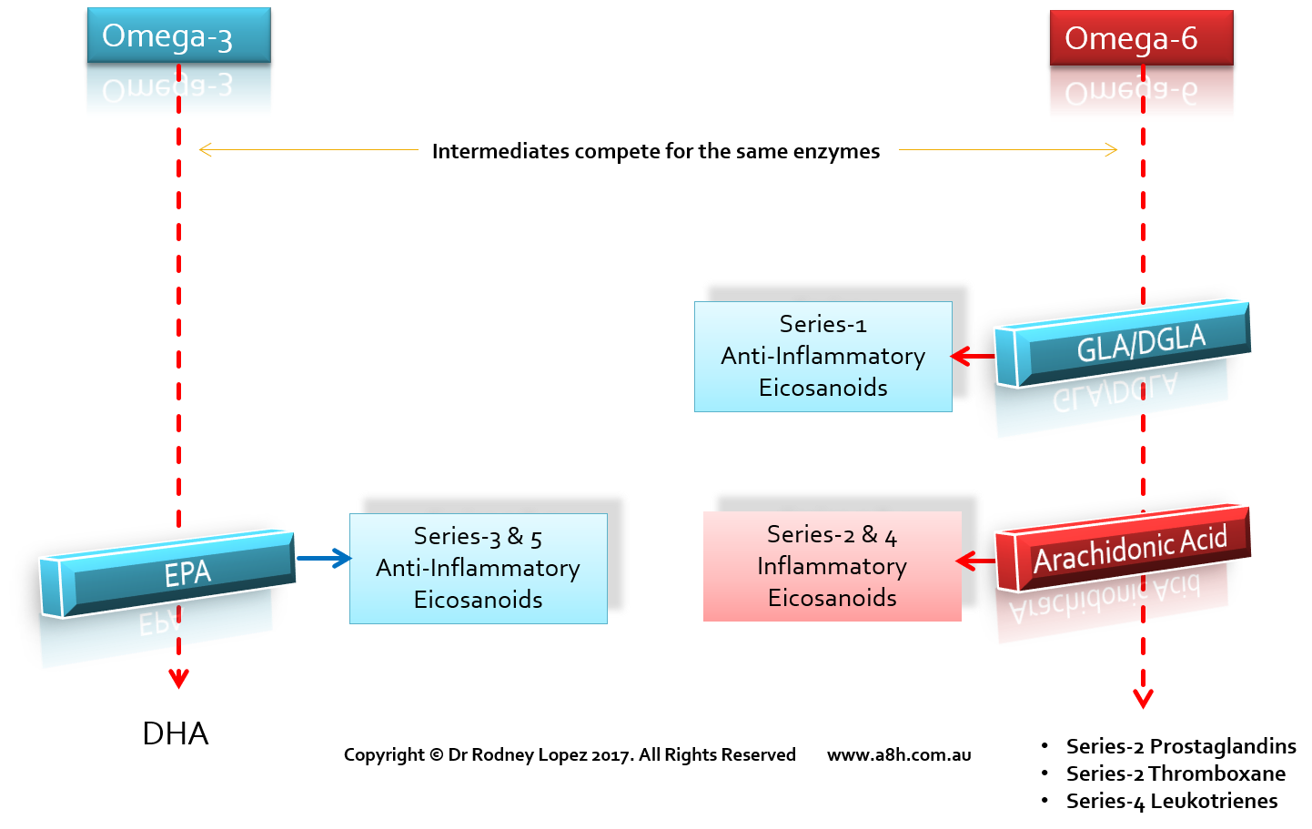

Other comments:

References
Aude, Y. W., A. S. Agatston, F. Lopez-Jimenez, E. H. Lieberman, M. Almon, M. Hansen, G. Rojas, G. A. Lamas and C. H. Hennekens (2004). "The national cholesterol education program diet vs a diet lower in carbohydrates and higher in protein and monounsaturated fat: a randomized trial." Archives of internal medicine 164(19): 2141.
Dunn, E. (2017). Lighting a fuse on the lipid debate. Medical Observer, Fairfax Media.
Simopoulos, A. P. (2002). "The importance of the ratio of omega-6/omega-3 essential fatty acids." Biomed Pharmacotherapy 56(8): 365-379.
Spence, J. D. (2002). "Importance of diet in vascular prevention: vastly underestimated." Circulation 106(18): e133-e133.

